**Installation of Microsoft SQL server and Management Studio**.

Step 1 : Go to Devops and click on Wiki to select Azure Installation of Optiqs360.

Step 2 : Click on Download SSMS (SQL Server Management Studio) <https://docs.microsoft.com/en-us/sql/ssms/download-sql-server-management-studio-ssms?view=sql-server-ver15>

Step 3: Click to Download SQL Server option on Top Right which placed below on signin option

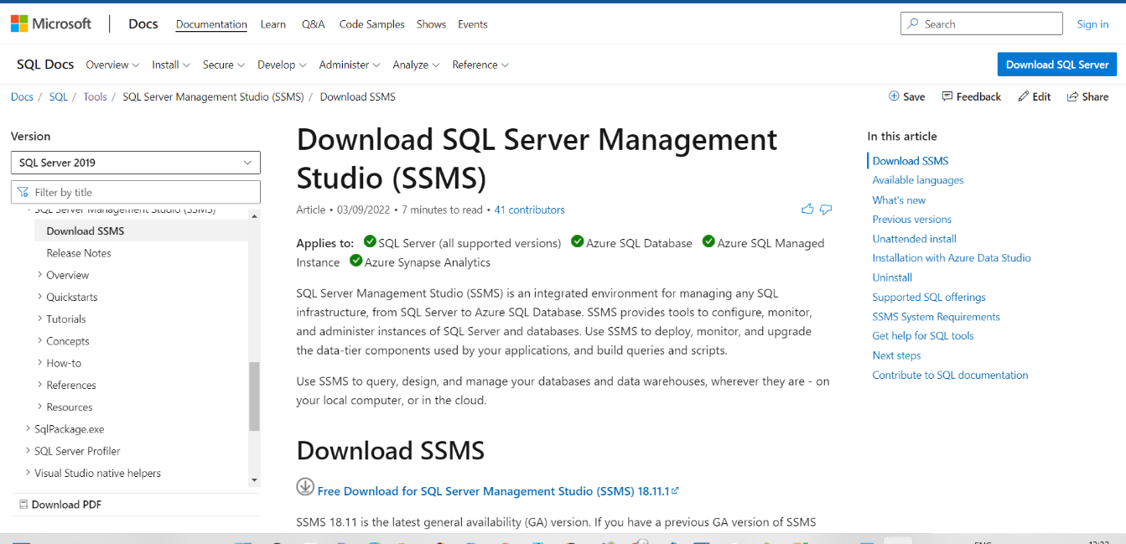

Step 4: After downloaded to install with select basic option.

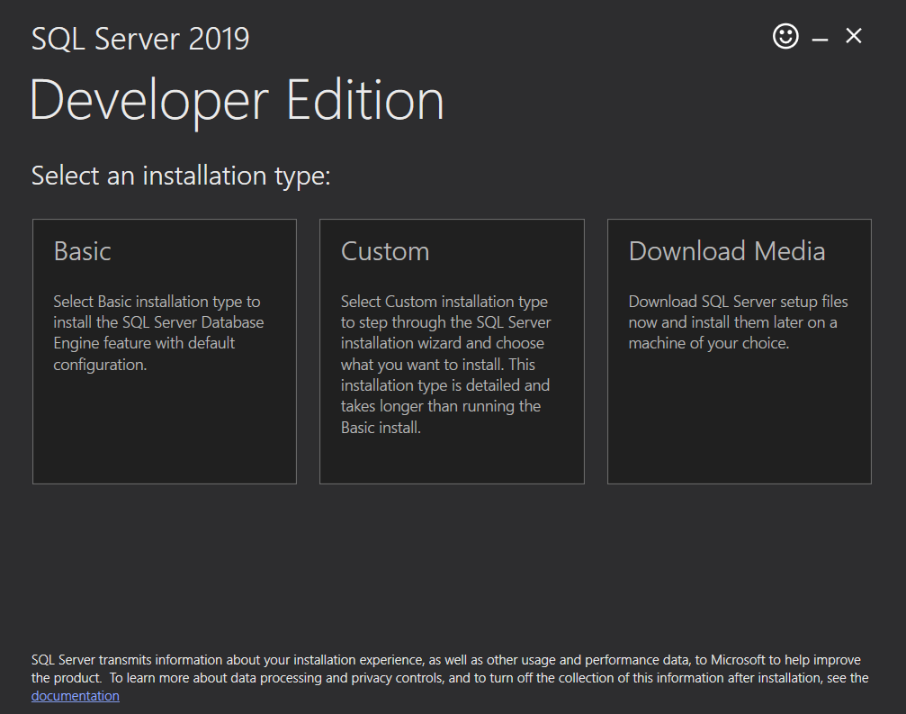

Step 5: Download setup file which placed same browser page 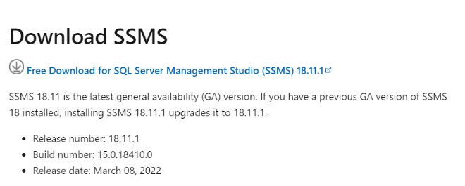

Step 6 : install the setup file and use developer option and get a new window that are given below.

Step 7 : By default you login with “sa” option and if you need a new login just right click on logins option and select new login.

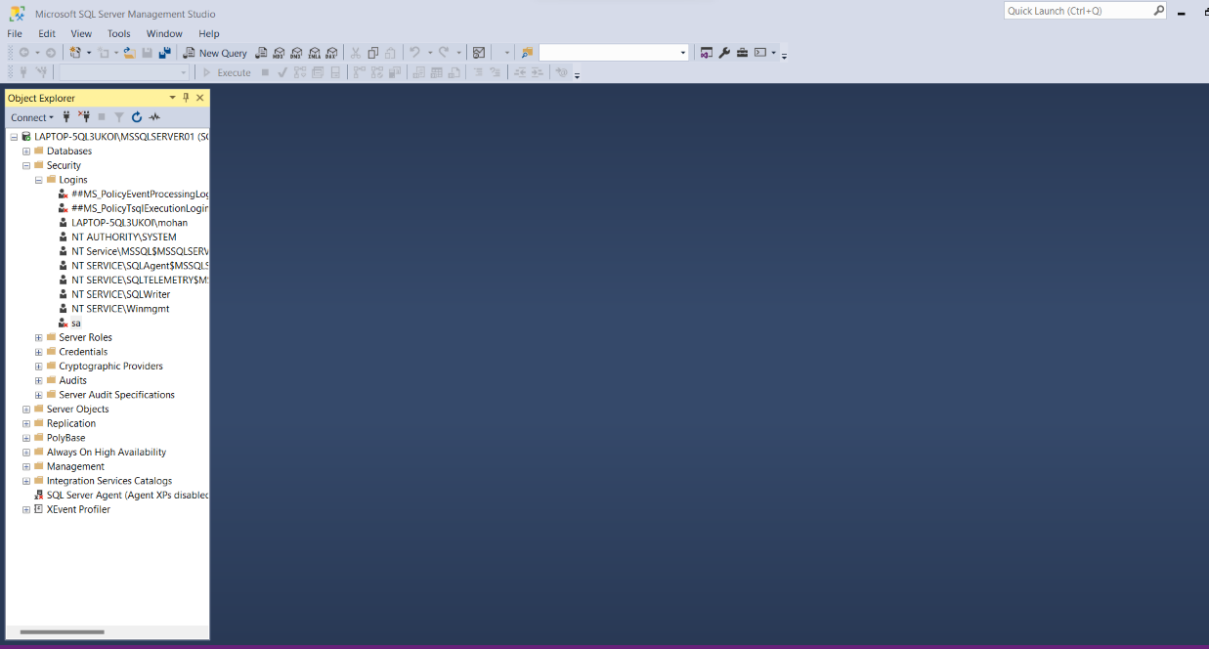

Step 8 : If the Connect is not available in Object Explorer. Please follow the below step.

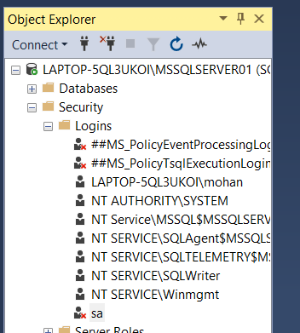

Step 9 : please check the protocols for MSSQLSERVER TCP/IP (note: if they are in disabled please change into enabled) example picture given below:

